**Overview**

**WWW** stands for **World Wide Web.** A technical definition of the World Wide Web is : all the resources and users on the Internet that are using the Hypertext Transfer Protocol (HTTP).

A broader definition comes from the organization that Web inventor **Tim Berners-Lee** helped found, the **World Wide Web Consortium (W3C).**

The World Wide Web is the universe of network-accessible information, an embodiment of human knowledge.

In simple terms, The World Wide Web is a way of exchanging information between computers on the Internet, tying them together into a vast collection of interactive multimedia resources.

**Internet** and **Web** is not the same thing: Web uses internet to pass over the information.

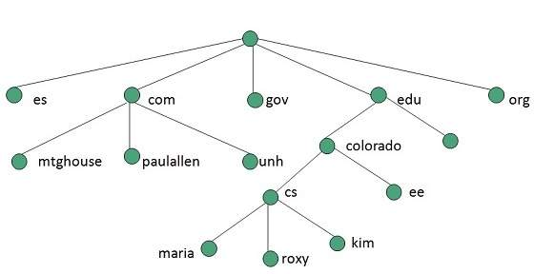

**Evolution**

**World Wide Web** was created by **Timothy Berners Lee** in 1989 at **CERN** in **Geneva.** World Wide Web came into existence as a proposal by him, to allow researchers to work together effectively and efficiently at **CERN.** Eventually it became **World Wide Web.**

The following diagram briefly defines evolution of World Wide Web:

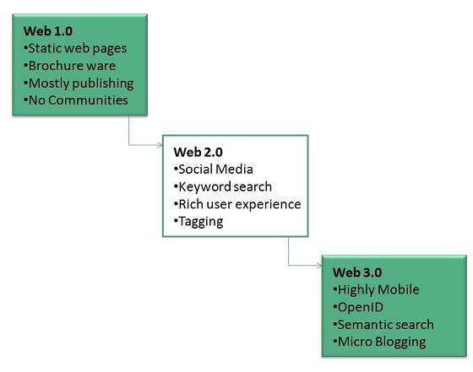

**WWW Architecture**

WWW architecture is divided into several layers as shown in the following diagram:

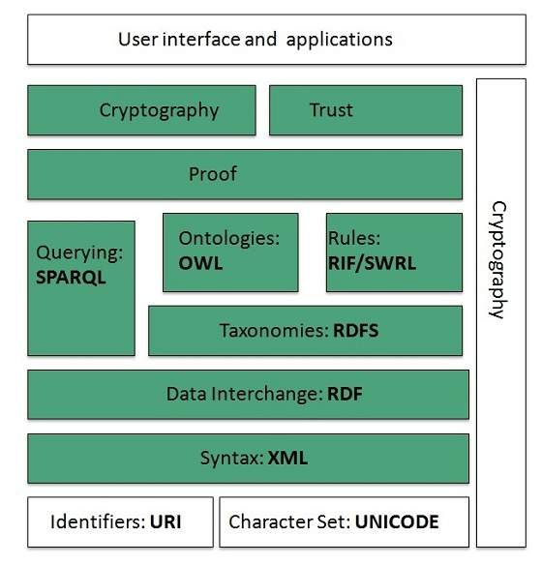

**Identifiers and Character Set**

**Uniform Resource Identifier (URI)** is used to uniquely identify resources on the web and **UNICODE** makes it possible to built web pages that can be read and write in human languages.

**Syntax**

**XML (Extensible Markup Language)** helps to define common syntax in semantic web.

**Data Interchange**

**Resource Description Framework (RDF)** framework helps in defining core representation of data for web. RDF represents data about resource in graph form.

**Taxonomies**

**RDF Schema (RDFS)** allows more standardized description of **taxonomies** and other **ontological** constructs.

**Ontologies**

**Web Ontology Language (OWL)** offers more constructs over RDFS. It comes in following three versions:

* OWL Lite for taxonomies and simple constraints.
* OWL DL for full description logic support.
* OWL for more syntactic freedom of RDF

**Rules**

**RIF** and **SWRL** offers rules beyond the constructs that are available from **RDFs** and **OWL.** Simple Protocol and **RDF Query Language (SPARQL)** is SQL like language used for querying RDF data and OWL Ontologies.

**Proof**

All semantic and rules that are executed at layers below Proof and their result will be used to prove deductions.

**Cryptography**

**Cryptography** means such as digital signature for verification of the origin of sources is used.

**User Interface and Applications**

On the top of layer **User interface and Applications** layer is built for user interaction.

**WWW Operation**

**WWW** works on client- server approach. Following steps explains how the web works:

1. User enters the URL (say, **http://www.cityuniversity.com**) of the web page in the address bar of web browser.
2. Then browser requests the Domain Name Server for the IP address corresponding to www.cityuniversity.com.
3. After receiving IP address, browser sends the request for web page to the web server using HTTP protocol which specifies the way the browser and web server communicates.
4. Then web server receives request using HTTP protocol and checks its search for the requested web page. If found it returns it back to the web browser and close the HTTP connection.
5. Now the web browser receives the web page, It interprets it and display the contents of web page in web browser’s window.

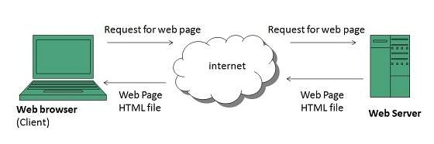

**Future**

There had been a rapid development in field of web. It has its impact in almost every area such as education, research, technology, commerce, marketing etc. So the future of web is almost unpredictable.

Apart from huge development in field of WWW, there are also some technical issues that W3 consortium has to cope up with.

**User Interface**

Work on higher quality presentation of 3-D information is under deveopment. The W3 Consortium is also looking forward to enhance the web to full fill requirements of global communities which would include all regional languages and writing systems.

**Technology**

Work on privacy and security is under way. This would include hiding information, accounting, access control, integrity and risk management.

**Architecture**

There has been huge growth in field of web which may lead to overload the internet and degrade its performance. Hence more better protocol are required to be developed.

## Web Page

**web page** is a document available on world wide web. Web Pages are stored on web server and can be viewed using a web browser.

A web page can cotain huge information including text, graphics, audio, video and hyper links. These hyper links are the link to other web pages.

Collection of linked web pages on a web server is known as **website.** There is unique **Uniform Resource Locator (URL)** is associated with each web page.

### Static Web page

**Static web pages** are also known as flat or stationary web page. They are loaded on the client’s browser as exactly they are stored on the web server. Such web pages contain only static information. User can only read the information but can’t do any modification or interact with the information.

Static web pages are created using only HTML. Static web pages are only used when the information is no more required to be modified.

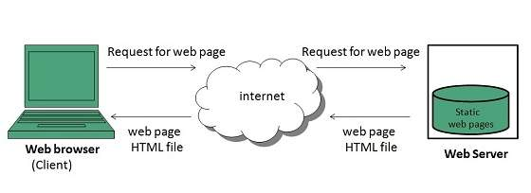

### Dynamic Web page

**Dynamic web page** shows different information at different point of time. It is possible to change a portaion of a web page without loading the entire web page. It has been made possible using **Ajax** technology.

#### Server-side dynamic web page

It is created by using server-side scripting. There are server-side scripting parameters that determine how to assemble a new web page which also include setting up of more client-side processing.

#### Client-side dynamic web page

It is processed using client side scripting such as JavaScript. And then passed in to **Document Object Model (DOM).**

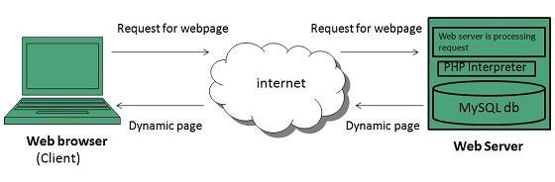

# Web Server

**Web server** is a computer where the web content is stored. Basically web server is used to host the web sites but there exists other web servers also such as gaming, storage, FTP, email etc.

Web site is collection of web pages while web server is a software that respond to the request for web resources.

**Web Server Working**

Web server respond to the client request in either of the following two ways:

* Sending the file to the client associated with the requested URL.
* Generating response by invoking a script and communicating with database

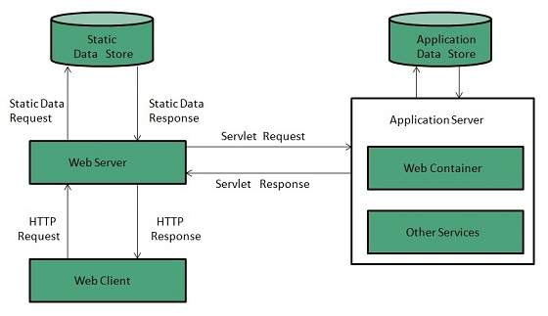

**Key Points**

* When client sends request for a web page, the web server search for the requested page if requested page is found then it will send it to client with an HTTP response.
* If the requested web page is not found, web server will the send an **HTTP response:Error 404 Not found.**
* If client has requested for some other resources then the web server will contact to the application server and data store to construct the HTTP response.

**Architecture**

Web Server Architecture follows the following two approaches:

1. Concurrent Approach
2. Single-Process-Event-Driven Approach.

**Concurrent Approach**

Concurrent approach allows the web server to handle multiple client requests at the same time. It can be achieved by following methods:

* Multi-process
* Multi-threaded
* Hybrid method.

**Multi-processing**

In this a single process (parent process) initiates several single-threaded child processes and distribute incoming requests to these child processes. Each of the child processes are responsible for handling single request.

It is the responsibility of parent process to monitor the load and decide if processes should be killed or forked.

**Multi-threaded**

Unlike Multi-process, it creates multiple single-threaded process.

**Hybrid**

It is combination of above two approaches. In this approach multiple process are created and each process initiates multiple threads. Each of the threads handles one connection. Using multiple threads in single process results in less load on system resources.

**Examples**

Following table describes the most leading web servers available today:

|  |  |
| --- | --- |
| **S.N.** | **Web Server Descriptino** |
| 1 | **Apache HTTP Server** This is the most popular web server in the world developed by the Apache Software Foundation. Apache web server is an open source software and can be installed on almost all operating systems including Linux, UNIX, Windows, FreeBSD, Mac OS X and more. About 60% of the web server machines run the Apache Web Server. |
| 2. | **Internet Information Services (IIS)** The Internet Information Server (IIS) is a high performance Web Server from Microsoft. This web server runs on Windows NT/2000 and 2003 platforms (and may be on upcoming new Windows version also). IIS comes bundled with Windows NT/2000 and 2003; Because IIS is tightly integrated with the operating system so it is relatively easy to administer it. |
| 3. | **Lighttpd** The lighttpd, pronounced lighty is also a free web server that is distributed with the FreeBSD operating system. This open source web server is fast, secure and consumes much less CPU power. Lighttpd can also run on Windows, Mac OS X, Linux and Solaris operating systems. |
| 4. | **Sun Java System Web Server** This web server from Sun Microsystems is suited for medium and large web sites. Though the server is free it is not open source. It however, runs on Windows, Linux and UNIX platforms. The Sun Java System web server supports various languages, scripts and technologies required for Web 2.0 such as JSP, Java Servlets, PHP, Perl, Python, and Ruby on Rails, ASP and Coldfusion etc. |
| 5. | **Jigsaw Server** Jigsaw (W3C's Server) comes from the World Wide Web Consortium. It is open source and free and can run on various platforms like Linux, UNIX, Windows, and Mac OS X Free BSD etc. Jigsaw has been written in Java and can run CGI scripts and PHP programs. |